

CEBU EASTERN COLLEGE, INC.
Leon Kilat St., Pahina Central, Cebu, City, Cebu, Philippines
COLLEGE OF INFORMATION TECHNOLOGY
Email Address: cecitdepartment@gmail.com

FREE ELEC 1 BUSINESS ANALYTICS
A Feasibility Study on the Establishment of
Siago – Siomai on the Go

By:

Mabini, Liwince T.
Pielago, John Paul N.
Lubas, Andre Ralph T.
Sanchez, Jhon Lloyd N.
Dela Paz, Ranz Rainier E.

BSIT – 3 Section 11
FS (7:30 - 9:00 PM)

Instructors name:
Jeorge Rey Mancilla

Date submitted:
September 29, 2026

Business Concept
Business Name: Siago – Siomai on the Go
Business Type: Food/Snack Business
Business Description: Siago – Siomai on the Go is a proposed food business that specializes in serving siomai as an affordable and convenient snack or meal. The business is designed to provide customers with quick food options that can be easily purchased and consumed, especially during busy school or work schedules. Siago will focus on offering siomai in different serving sizes and meal combinations to provide customers with practical choices.
Problem/Customer Need: Students and other busy customers often need food that is quick, convenient, affordable, and satisfying. However, available food choices may not always provide a combination of convenience and variety that fits their needs. Siago aims to address this need by providing an easy-to-access food option centered on siomai that customers can purchase as either a snack or a simple meal.
Target Customers: The primary target customers of Siago are students, particularly senior high school and college students who commonly look for convenient and affordable food options during school hours.
The business may also serve teachers, school staff, workers, and other nearby customers who want a quick snack or meal.
Proposed Solution: Siago will offer siomai-based food options that customers can purchase conveniently as a snack or meal. The business will provide different serving sizes and possible combinations, such as siomai with rice or drinks, allowing customers to choose an option that suits their needs.
The business will focus on convenience, affordability, accessibility, and food quality as important aspects of its service.
Unique Selling Proposition (USP): “Siago – Siomai on the Go provides convenient and affordable siomai options made for customers who want a quick and satisfying snack or meal.”
The main idea of the USP is to make Siago a simple, accessible, and convenient siomai option, particularly for students and people with busy schedules.

Market Research
Market: The market for Siago – Siomai on the Go consists primarily of customers who are looking for affordable, convenient, and satisfying food options that can be purchased quickly. The business is positioned within the quick-service food and snack market, with siomai as its main product. Its potential market includes students, school employees, workers, and other individuals within or near the school and surrounding community who may need a convenient snack or meal during their daily activities. Siago can serve customers who prefer simple food choices that are easy to purchase and consume, while also offering different serving sizes and meal combinations to accommodate different customer needs.
Target Customers: The primary target customers of Siago are senior high school and college students, particularly those who regularly need convenient food options during school hours. Students are an appropriate target market because they often have limited time between classes and may look for food that is easy to purchase and consume. Secondary target customers include teachers, school staff, employees, and other nearby consumers who are looking for a quick snack or meal. By focusing on customers within the school and nearby community, Siago can position itself as an accessible and convenient food option for people with busy daily schedules.

Competitors:
Competitor 1: Master Siomai
Products/Services: Pork & shrimp siomai, beef siomai, chicken siomai, Japanese siomai, chili sauce; food-cart/service format.
Price Range: Around ₱75–₱85+ per serving based on current Cebu online listings; prices vary by branch/platform.
Target Customers: General consumers, students, workers, and people looking for quick snacks/meals
Strengths: Established brand, recognizable name, several siomai variants, food-cart format, multiple locations
Weaknesses: Established menu and brand may be less specifically focused on the preferences of students in the target school area. Its prices may also be above some respondents' preferred spending levels.
Competitor 2: Siomai House
Products/Services: Pork-shrimp siomai, siomai solo, siomai + drink set, rice, drinks, chili garlic
Price Range: ₱84 for 4 pcs solo; ₱104 for 4 pcs + drink; ₱12 rice; ₱24 soft drink in the Talisay listing.
Target Customers: General consumers, mall-goers, students, workers, and customers looking for quick food
Strengths: Offers both solo and combo options, has rice and drinks, recognizable siomai-focused business, has a Cebu-area branch
Weaknesses: Its listed serving/combo prices may not match every student's preferred budget. Siago can investigate more suitable serving sizes and combinations through its survey.
Competitor 3: Dimsum Treats
Products/Services: Different siomai varieties, dumplings/dimsum, rice meals, drinks, and other food products
Price Range: Approximately ₱95–₱100 for some siomai products and around ₱145–₱150 for selected siomai meal combinations based on the earlier competitor research.
Target Customers: General consumers looking for snacks, dimsum, and complete meals
Strengths: Wider food selection, different siomai varieties, offers meals in addition to individual products
Weaknesses: Broader menu means it is not primarily focused on a student-specific siomai concept. Its meal prices can also be higher than the lower spending ranges identified by some survey respondents.
Survey Methodology: The study used a quantitative descriptive survey method to gather information about potential customers' preferences and purchasing behavior toward the proposed Siago siomai business. A structured online questionnaire was used to collect data regarding respondents' demographic profile, siomai consumption, preferred serving sizes, preferred product combinations, preferred siomai types, willingness to pay, purchasing factors, interest in Siago, purchase likelihood, preferred location, and purchasing method.
The survey responses were organized and analyzed using frequency counts and percentages. The results will be used to identify customer preferences, acceptable price ranges, potential demand, and other factors that can support Siago's product and pricing decisions.
Respondents: The survey obtained 34 responses. The respondents were composed mainly of students and other individuals within the intended market. The respondents included 19 college students, 5 working students, 4 senior high school students, 3 employed respondents, and 3 respondents under other categories.

Data Collection & Preparation
Raw Data
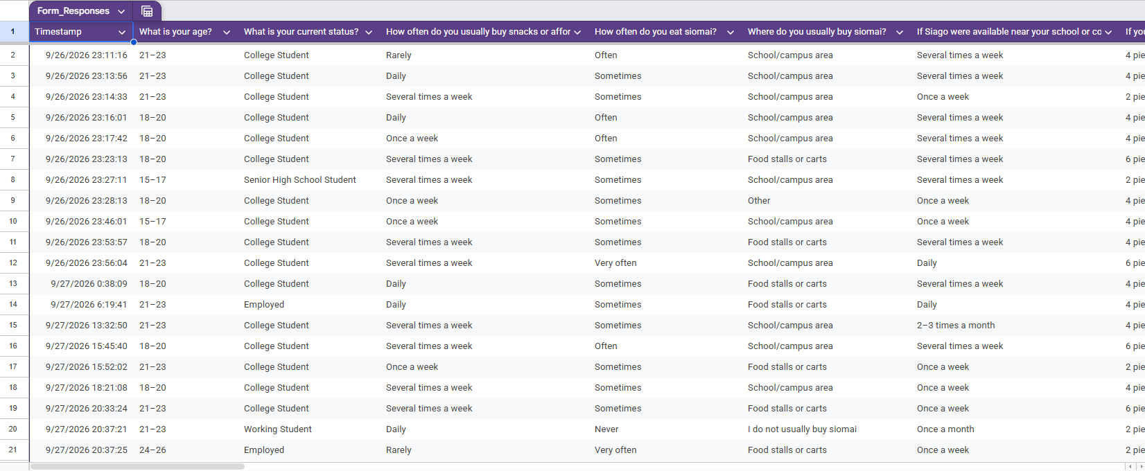
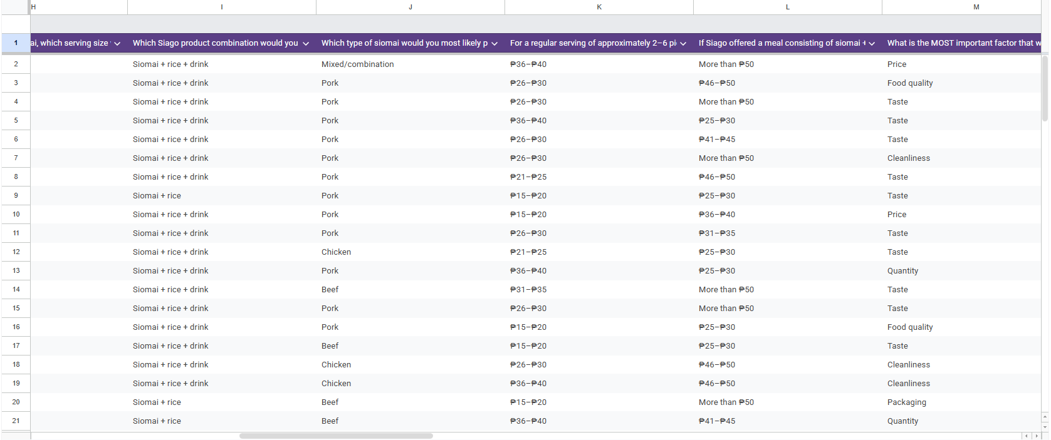
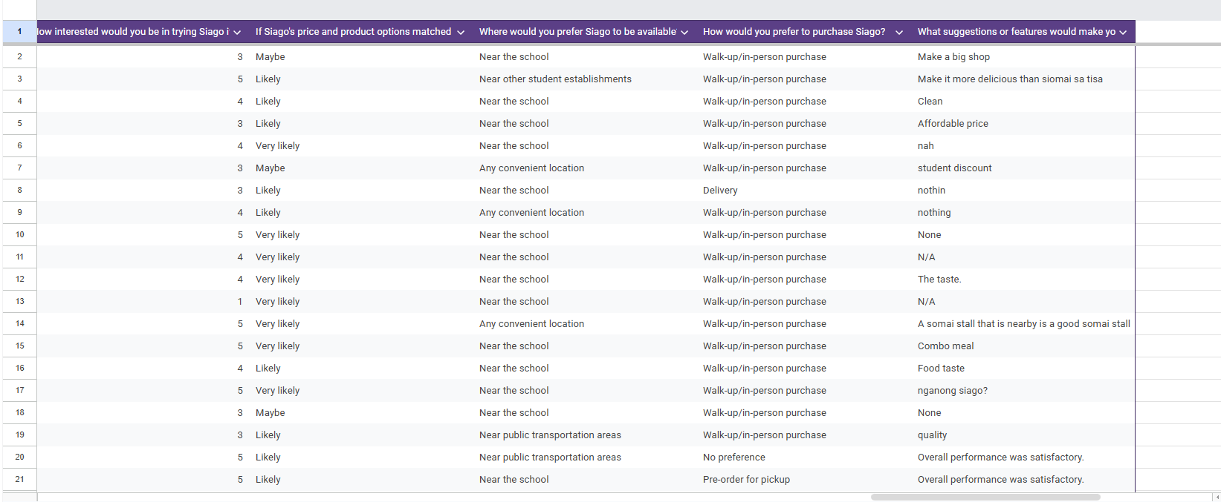
Cleaned Data
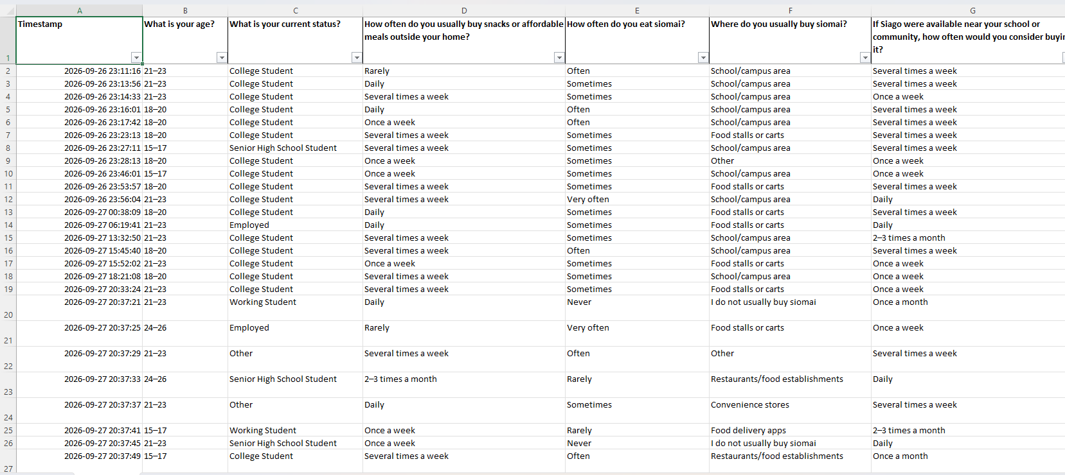
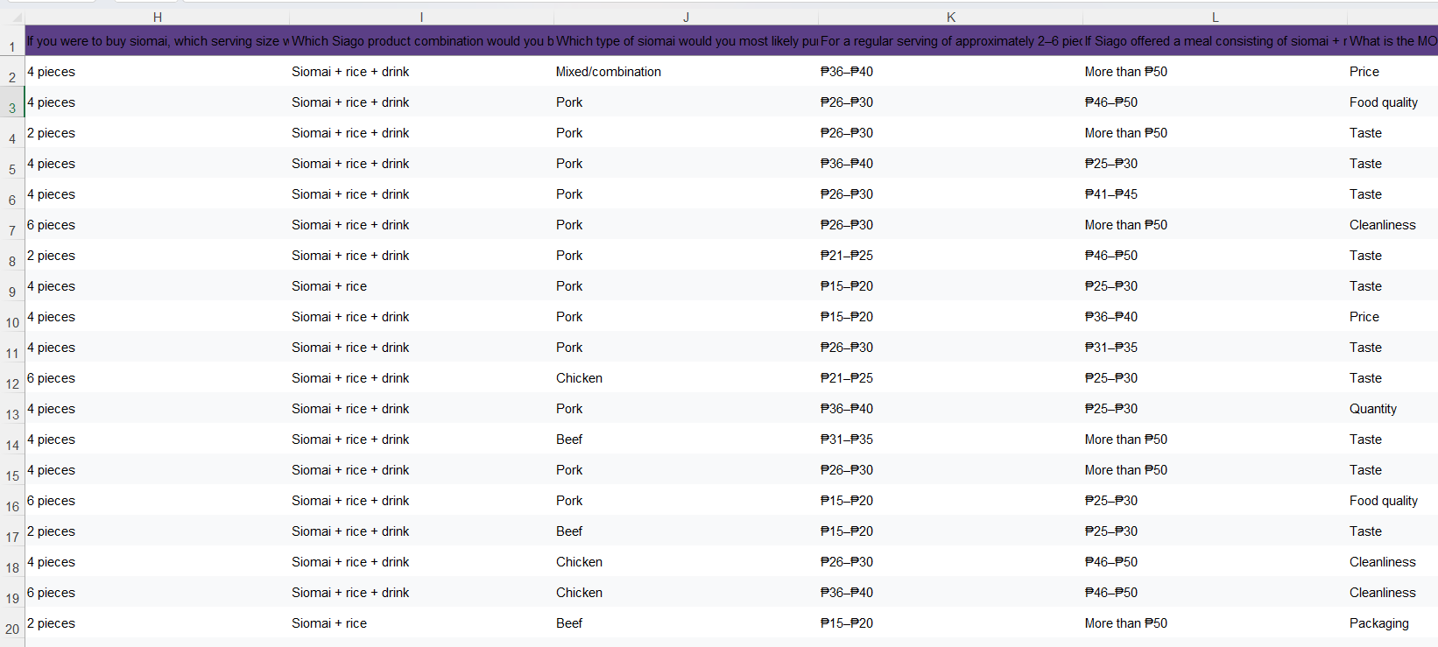
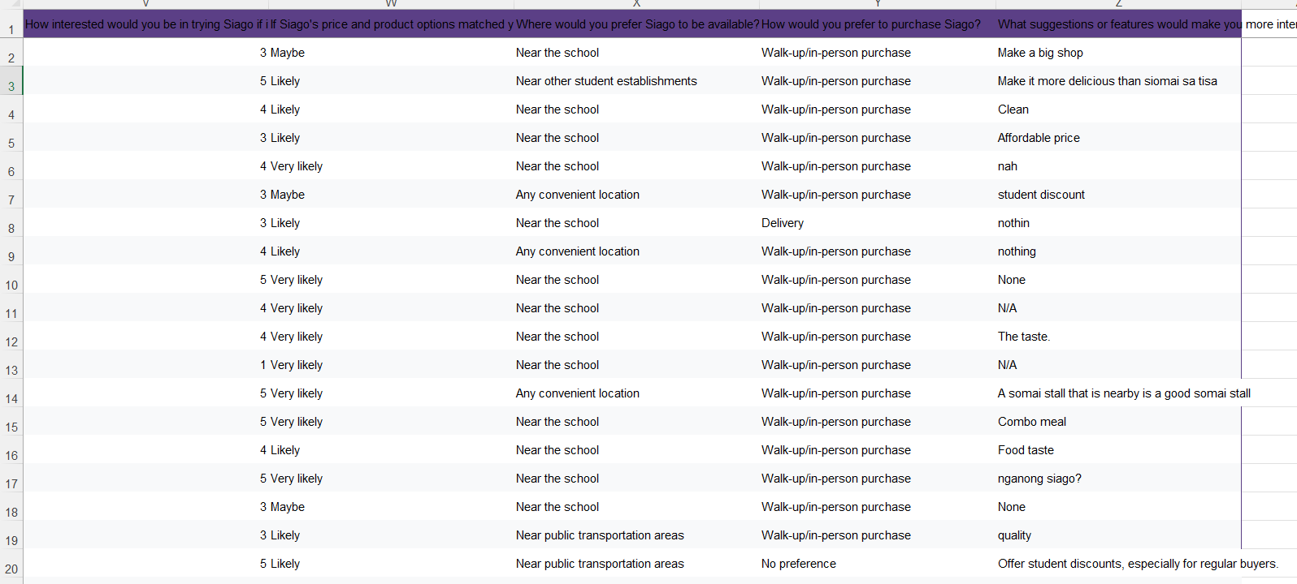
Survey: A quantitative descriptive survey was conducted to collect information about the potential market for Siago – Siomai on the Go. The survey gathered responses about the respondents’ age, current status, frequency of purchasing snacks or affordable meals, siomai consumption habits, preferred serving sizes, preferred product combinations, preferred siomai type, willingness to pay, purchasing factors, interest in Siago, likelihood of purchasing, preferred location, and preferred purchasing method.
A total of 34 respondents were included in the dataset. The respondents were composed mainly of college students, with 19 college students, 5 working students, 4 senior high school students, 3 employed respondents, and 3 respondents under other status.

Data Collection Process: The survey was distributed online and responses were recorded in an Excel dataset. The collected information was organized according to each survey question. The survey focused on customer preferences, purchasing behavior, acceptable prices, product preferences, and potential interest in Siago.
The dataset contains 34 responses and 26 columns, including respondent information, purchasing behavior, product preferences, price preferences, importance ratings, interest in Siago, purchase likelihood, preferred availability, purchasing method, and suggestions.
Data Cleaning: The collected dataset was checked and organized before analysis. The following data preparation techniques were applied:
a. Duplicate checking – The 34 responses were checked for duplicate entries. No exact duplicate respondent records were identified.
b. Missing-value checking – Each column was reviewed for blank responses. The completed dataset contains responses for the importance-rating questions for all 34 respondents. Blank responses in optional/open-ended fields were retained as blank rather than assigning an answer that the respondent did not provide.
c. Formatting correction – Text entries were reviewed for unnecessary spaces and inconsistent formatting. The timestamp and response fields were organized into a consistent format.
d. Response standardization – Similar categorical responses were checked to ensure that the same response choices were grouped consistently. For example, choices such as purchasing method, product combination, preferred serving size, and willingness-to-pay ranges were retained using their original survey categories.
e. Dataset validation – The final dataset contains exactly 34 respondents, matching the number of respondents reported for the market research.
Dataset Description: The final dataset consists of 34 respondents and 26 survey variables. The variables include demographic information, purchasing frequency, siomai preferences, serving size, product combinations, preferred siomai type, willingness to pay, purchasing factors, importance ratings, interest in Siago, purchase likelihood, preferred location, purchasing method, and suggestions.
The dataset contains mainly categorical responses and rating-based responses. Frequency counts and percentages were used to summarize the categorical data and identify patterns that can support the business decision.

Data Analysis
Using Microsoft Excel, the cleaned dataset was analyzed to extract actionable business insights.
Finding 1 (Demographics): The largest age group among the respondents is 21–23 years old, with 14 respondents. The smallest group is 24–26 years old, with 5 respondents.
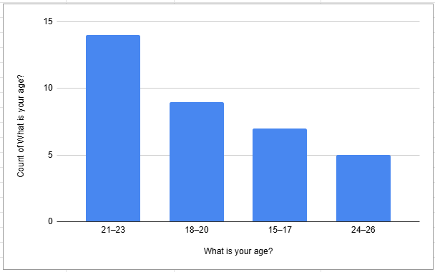Table 1. Frequency of Age
Interpretation: The respondents are mostly within the young adult age group, particularly those aged 21–23. This is relevant because Siago is intended to serve students and other customers who need convenient and affordable food options.
Insight:The results suggest that Siago can focus its products and promotions on young customers, especially students, since they represent a large portion of the respondents and are part of the intended target market.
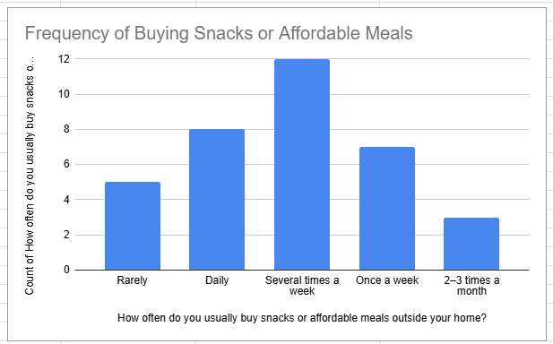Table 2: Frequency of Buying Snacks or Affordable Meals
Finding 2 (Purchase Timing): The largest group, 12 respondents, buys snacks or affordable meals several times a week. Eight respondents reported buying them daily.
Interpretation: The responses show that purchasing snacks or affordable meals outside the home is a regular activity for many respondents. This provides context for the potential demand for a convenient food product.
Insight: This indicates that there is an existing habit of purchasing affordable food among the respondents. Siago can use this behavior as a basis for offering a convenient food option that can be purchased during school or work schedules.
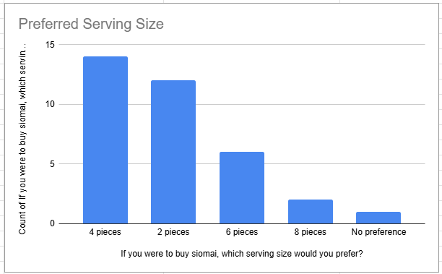Table 3: Preferred Serving Size
Finding 3 (Product Preference): The most preferred serving size is 4 pieces, selected by 13 respondents, followed by 2 pieces with 12 respondents.
Interpretation: The results show stronger preference for the smaller serving options, particularly 2 and 4 pieces. These options may therefore be considered when planning the product sizes for Siago.
Insight: Siago can prioritize 2-piece and 4-piece serving options because these were the most selected choices. Offering different serving sizes can also allow customers to choose according to their appetite and budget.

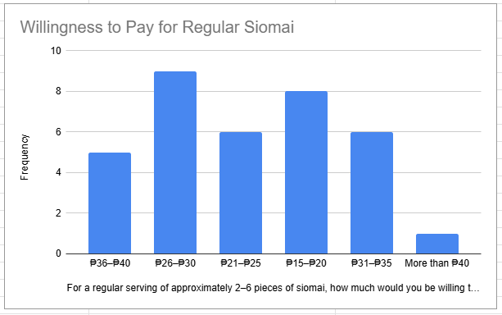Table 4: Willingness to Pay for Regular Siomai
Finding 4 (Pricing Tolerance): The ₱26–₱30 range received the highest number of responses, with 9 respondents.
Interpretation: The results show that ₱26–₱30 was the most frequently selected price range for a regular serving. However, the responses are distributed across several price ranges, so the final selling price should also consider actual product costs, operating expenses, and financial feasibility.
Insight: The ₱26–₱30 range can serve as a useful reference when planning the regular product price. However, the final price should still consider the actual cost of ingredients, operating expenses, and the financial assumptions used in the feasibility study.
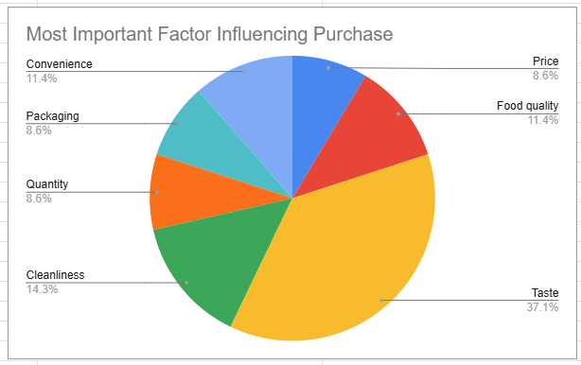Table 5: Most Important Factor Influencing Purchase

Finding 5 (Purchasing Barriers): Taste is the most frequently selected factor, with 12 respondents. Cleanliness follows with 5 respondents.
Interpretation: The results indicate that taste is the most commonly identified factor that could influence the respondents' purchasing decision. Cleanliness, food quality, and convenience were also selected by respondents, showing that purchasing decisions are influenced by several product and service characteristics.

Insight: Siago should give strong attention to taste, cleanliness, food quality, and convenience because these factors are directly related to what respondents considered when deciding whether to purchase the product.

Financial Feasibility
The survey supports the product direction: the most selected regular-serving willingness-to-pay range was ₱26–₱30, while Siomai + rice + drink was the most preferred combination with 20 of 34 respondents. The final prices below are therefore planning assumptions, not claimed final market prices.
Estimated Startup Capital
Startup Requirement | Estimated Cost
Small food stall/table/cart setup | ₱2,500
Food steamer | ₱1,500
Rice cooker | ₱1,200
Cooler/storage container | ₱800
Cooking utensils and serving tools | ₱700
Initial siomai, rice, drinks and ingredients | ₱2,500
Initial food packaging and containers | ₱800
Basic permits/registration allowance | ₱1,000
Signage/menu board | ₱500
Contingency/emergency fund | ₱1,000
Total Estimated Startup Capital | ₱12,500
Estimated Monthly Expenses
Fixed Expense | Monthly Cost
Stall/space rental | ₱2,500
Electricity and water | ₱800
Mobile/data/communication | ₱300
Permit/registration allocation | ₱300
Marketing/promotional materials | ₱300
Total Fixed Expenses | ₱4,200

Expense Category | Amount
Fixed Expenses | ₱4,200
Variable Expenses | ₱12,168
Total Estimated Expenses | ₱16,368

These increase as more products are sold.
For the projection, let's assume two main product categories:
Product | Assumed Selling Price | Estimated Variable Cost
Regular Siomai Serving | ₱25 | ₱12
Siomai + Rice + Drink | ₱30 | ₱18

Sales and Variable Cost Assumptions
The survey showed that ₱26–₱30 was the most selected WTP for regular siomai, while ₱25–₱30 was one of the selected ranges for the meal combination. Based on this, the feasibility model uses ₱25 for regular siomai and ₱30 for the meal combination.
For monthly sales, the study assumes 30 servings per day for 26 operating days, resulting in 780 servings per month.
- 40% regular servings = 312 servings
- 60% meal combinations = 468 servings
Revenue
Product | Calculation | Revenue
Regular Siomai | 312 × ₱25 | ₱7,800
Siomai + Rice + Drink | 468 × ₱30 | ₱14,040
Total Revenue |  | ₱21,840

Profit
Profit = Total Revenue − Total Expenses
₱21,840 − ₱16,368 = ₱5,472

Estimated Monthly Profit: ₱5,472

Risk Analysis
The following risks were identified based on the proposed operations, customer preferences, and financial assumptions of Siago – Siomai on the Go. The risks were evaluated according to their probability and potential impact on the business. Proposed solutions were also identified to help reduce the possible effects of each risk.
Risk | Probability | Impact | Proposed Solution
Low customer demand | Medium | High | Start with a small inventory and monitor daily sales. Adjust the amount of food prepared based on actual customer demand.
Increase in ingredient prices | Medium | High | Compare suppliers, control portions, and review the selling price when ingredient costs significantly increase.
Food spoilage and waste | Medium | Medium | Prepare products based on expected demand, store ingredients properly, and avoid preparing more food than necessary.
Food quality and cleanliness issues | Low | High | Maintain proper food handling, keep the preparation area clean, and regularly check the quality of ingredients and finished products.
Competition from other food sellers | High | Medium | Focus on consistent taste and quality, convenient serving options, reasonable pricing, and product combinations based on customer preferences.

Final Feasibility Decision
Decision: FEASIBLE
Based on the market research, product preferences, pricing responses, and financial projections, Siago – Siomai on the Go is considered feasible under the assumptions used in this study.
Validated Target Market: The survey results show a potential target market, particularly students and individuals who regularly purchase snacks or affordable meals. Out of 34 respondents, 19 were college students, making them the largest respondent group. In addition, 20 respondents selected siomai + rice + drink as their preferred product combination.
The survey also showed that 25 out of 34 respondents (73.5%) were either likely or very likely to purchase Siago if its price and product options matched their preferences. These results indicate potential customer demand, although actual sales may vary from survey intentions.
Confirmed Price Compatibility: The most frequently selected willingness-to-pay range for regular siomai was ₱26–₱30, with 9 respondents choosing this range. For the siomai, rice, and drink combination, ₱25–₱30 was selected by 9 respondents.
The proposed prices of ₱25 for regular siomai and ₱30 for the meal combination are therefore used as working assumptions in the financial analysis. These prices should still be reviewed based on actual ingredient and operating costs.
Actionable USP Alignment: Siago's proposed value proposition focuses on providing a convenient and affordable siomai-based snack or meal. The survey supports this direction, with siomai + rice + drink being the most preferred product combination. The preferred purchase method was also walk-up/in-person purchase, selected by 19 respondents.
These findings support offering simple, convenient, and accessible meal options based on customer preferences.
Financial Viability: The financial projection shows that Siago can potentially operate within the proposed assumptions. The estimated startup capital is ₱12,500, while estimated monthly expenses are ₱16,368.
With an estimated monthly revenue of ₱21,840, the projected monthly profit is approximately ₱5,472. Therefore, the financial projection indicates that the business can potentially generate a positive operating result if the assumed sales volume, prices, and costs are achieved.

Conclusion
Based on the combined results of the market research, product and pricing analysis, risk assessment, and financial feasibility analysis, Siago – Siomai on the Go is considered feasible under the assumptions of this study.
The business has a defined target market, survey evidence supporting customer interest and product preferences, price ranges that can guide the proposed pricing, and a financial projection showing positive estimated profit. However, feasibility remains dependent on actual customer demand, ingredient costs, operating expenses, and the ability of the business to maintain consistent food quality and cleanliness.
Overall, the study provides sufficient evidence to support moving forward with the proposed Siago business concept on a small-scale basis, while continuously monitoring sales, costs, customer feedback, and actual operating performance.

APPENDICES
Appendix A – Survey Questionnaire

SURVEY QUESTIONNAIRE

Siago – Siomai on the Go: Student Siomai Market Research Survey
Introduction:
Good day! We are conducting a market research survey for our Business Analytics feasibility study about Siago – Siomai on the Go. This survey aims to understand customers’ preferences, buying habits, price expectations, and level of interest in Siago. Your responses will be used for academic purposes only.

Part I – Respondent Profile
1. What is your age?
- 15–17
- 18–20
- 21–23
- 24–26
2. What is your current status?
- Senior High School Student
- College Student
- Working Student
- Employed
- Other

Part II – Buying Habits and Siomai Consumption
3. How often do you usually buy snacks or affordable meals outside your home?
- Daily
- Several times a week
- Once a week
- 2–3 times a month
- Rarely
4. How often do you eat siomai?
- Very often
- Often
- Sometimes
- Rarely
- Never
5. Where do you usually buy siomai?
- School/campus area
- Food stalls/kiosks
- Convenience stores
- Restaurants/fast-food establishments
- Other
6. If Siago were available near your school or community, how often would you consider buying it?
- Daily
- Several times a week
- Once a week
- 2–3 times a month
- Once a month
- Probably not

Part III – Product Preferences
7. If you were to buy siomai, which serving size would you prefer?
- 2 pieces
- 4 pieces
- 6 pieces
- 8 pieces
- No preference
8. Which Siago product combination would you be most interested in?
- Siomai only
- Siomai + rice
- Siomai + drink
- Siomai + rice + drink
- I prefer other combinations
9. Which type of siomai would you most likely purchase?
- Pork
- Chicken
- Beef
- Shrimp
- Mixed/combination
- No preference

Part IV – Price Preferences
10. For a regular serving of approximately 2–6 pieces of siomai, how much would you be willing to pay?
- ₱15–₱20
- ₱21–₱25
- ₱26–₱30
- ₱31–₱35
- ₱36–₱40
- More than ₱40
11. If Siago offered a meal consisting of siomai + rice + drink, how much would you be willing to pay?
- ₱25–₱30
- ₱31–₱35
- ₱36–₱40
- ₱41–₱45
- ₱46–₱50
- More than ₱50

Part V – Purchasing Factors
12. What is the MOST important factor that would influence your decision to buy Siago?
- Price
- Taste
- Quantity
- Convenience
- Cleanliness
- Food quality
- Packaging
13. Please rate how important each factor is when buying siomai.
Factor | Very Important | Important | Neutral | Slightly Important | Not Important
Price | ☐ | ☐ | ☐ | ☐ | ☐
Taste | ☐ | ☐ | ☐ | ☐ | ☐
Quantity | ☐ | ☐ | ☐ | ☐ | ☐
Convenience | ☐ | ☐ | ☐ | ☐ | ☐
Cleanliness | ☐ | ☐ | ☐ | ☐ | ☐
Food quality | ☐ | ☐ | ☐ | ☐ | ☐
Packaging | ☐ | ☐ | ☐ | ☐ | ☐
Location | ☐ | ☐ | ☐ | ☐ | ☐

Part VI – Customer Interest and Purchase Intention
14. How interested would you be in trying Siago if it became available near your school or community?
- 1 – Not Interested
- 2 – Slightly Interested
- 3 – Neutral
- 4 – Interested
- 5 – Very Interested
15. If Siago's price and product options matched your preferences, how likely would you be to purchase it?
- Very likely
- Likely
- Maybe
- Unlikely
- Very unlikely
16. Where would you prefer Siago to be available?
- Near the school
- Near other student establishments
- Near public transportation areas
- Near residential areas
- Any convenient location
17. How would you prefer to purchase Siago?
- Walk-up/in-person purchase
- Delivery
- Pre-order for pickup
- No preference

Part VII – Suggestions
18. What suggestions or features would make you more interested in buying Siago?

Appendix B – Survey Responses
